Description on how to download last-trade futures data of selective contracts from INO.com Exchanges:

If you do not want to download ALL the futures contracts for one market or from one exchange, but want to fetch data for selective futures, you can use the following method.

URLs used are similar to this one for Soybean Oil Oct 2008 contract:
http://quotes.ino.com/chart/?s=CBOT_BO.V08&v=s

Set-up:

- Copy the following line and append to your existing “mywebserver.txt”, or simply substitute it the attached “mywebserver.txt”. Most likely this line is already included.

Futures_INO,http://quotes.ino.com/chart/?s=SSSS&v=s,DL1,Futures_INO_DL1.fmt

- Replace the “Futures_INO_DL1.fmt” file in the “fmt” subfolder with the attached version.

- Run HSQuote Plus and set up the screen as soon. Please note that the portfolio name should be “Futures_INO.tic” as this is the ticker list name used in mywebserver.txt.

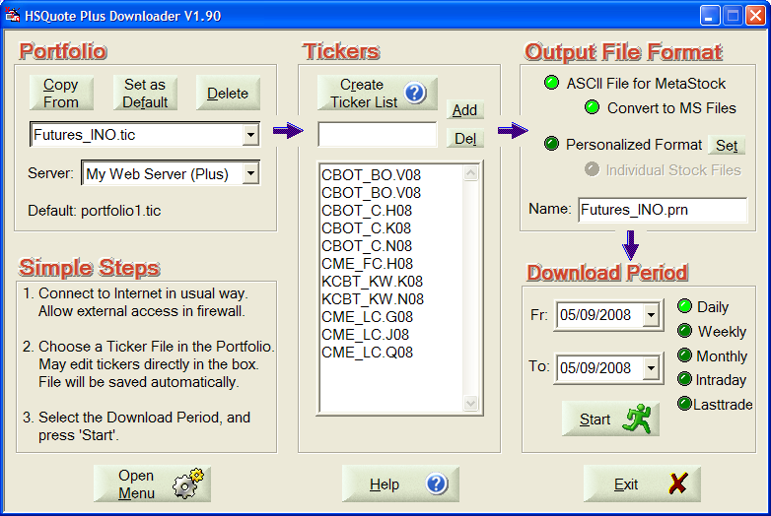

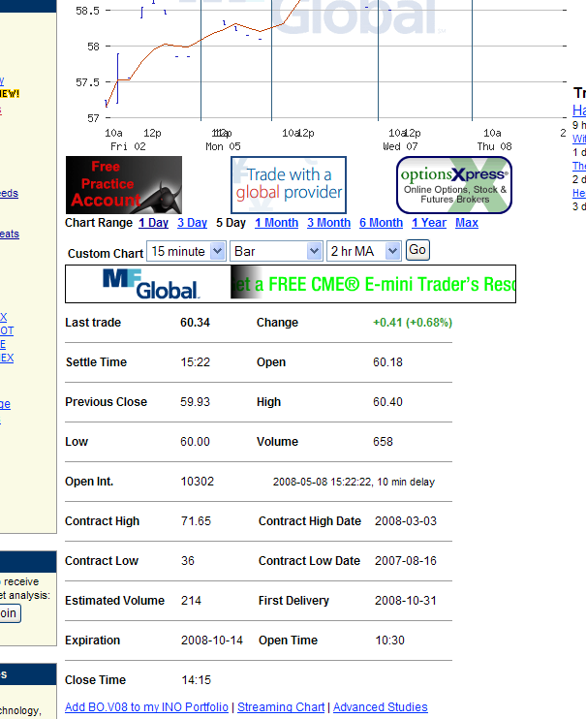

Last-Trade Daily Data Download:

This web page refreshes the last-trade data regularly. You may download in the middle of the session or at the end of the day. You need to do the download every day.

